A View of the Salt River Showing the Floods of 1980

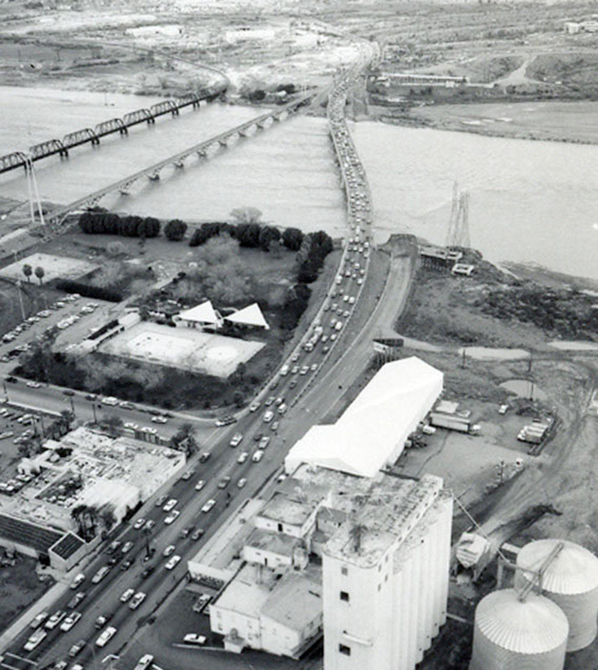

Things to notice about this photograph (this view is looking roughly NW):

1. The flow rate in the river was estimated to be as much as 180,000 CFS. The largest flood ever seen in this Valley was in 1891 with an estimated flow of nearly 300,000 CFS. A similar flood occurred in 1905 following nearly a decade of drought. The Salt River used to flow regularly with typically about 60,000 CFS during the wet season and sometimes not at all during dry periods. These waters are now impounded behind a system of dams on the Salt and Verde rivers (constructed from ~1905-1930) and water released is diverted into the canal system at Granite Reef dam. Tempe Town lake does not yet exist. What you see is the full flow of the river bounded by the natural river bank.
2. The Hayden flour mill is in full operation and all buildings are present and complete. (The wooden structures were lost in a fire in the 1990s after the mill closed.) Notice the steel silos behind the concrete silos (which were built ~1953). The concrete pads for these can still be seen. The store area is also still present. (It burned down after the mill closed, leaving only the older concrete structure.)
3. Rio Salado Parkway does not yet exist.
4. Mill Ave is still four lanes (two each direction) and the landscaping now found along the sidewalks and the center median is not present.
5. The old lap pool and wading pool in Tempe Beach Park are still present.
6. There is no development visible on the north bank of the river. (It is farther off.)
7. The Red Mountain Freeway (Loop 202) does not yet exist. It would not open until 1994.
8. The light rail bridge does not yet exist. This was not constructed until about 2005.
9. The old wagon bridge is still in place (between the rail bridge and the cars). The south abutment at the left of the picture still survives as part of Temp Beach Park. The bridge was originally built in ~1920 using convict labor, was obsolete the day it was open with vehicles getting heavier but maintained as a foot bridge. It was damaged beyond a practical ability to repair in a cost effective manner in flooding in 1991 and finally demolished.
10. There is only one auto bridge across the Salt River. The eastern portion of the road is not a bridge that has washed out, rather, it is a river bed crossing that has been flooded. The east bridge as we see it today was not built until the 1990s. In fact, in 1993 when that bridge was under construction, another large flood would wash away much of the early construction work for that span.
11. After these floods, it was realized that the ageing dams on the Salt system posed a potential hazard if floods of this magnitude were to recur with any regularity. Additionally, development of the Salt River Valley had reached a point where such floods caused quite considerable property damage and loss of business. A project was initiated to recondition these dams and to enlarge Roosevelt dam in order to give it more capacity to capture floods while still providing sufficient long term storage for irrigation and municipal needs. That is why the masonry face of Roosevelt dam is now covered with concrete. Thus, with this enlargement, it is unlikely floods of this sort will ever be seen in the Valley again.